WHERE CLAUSE:
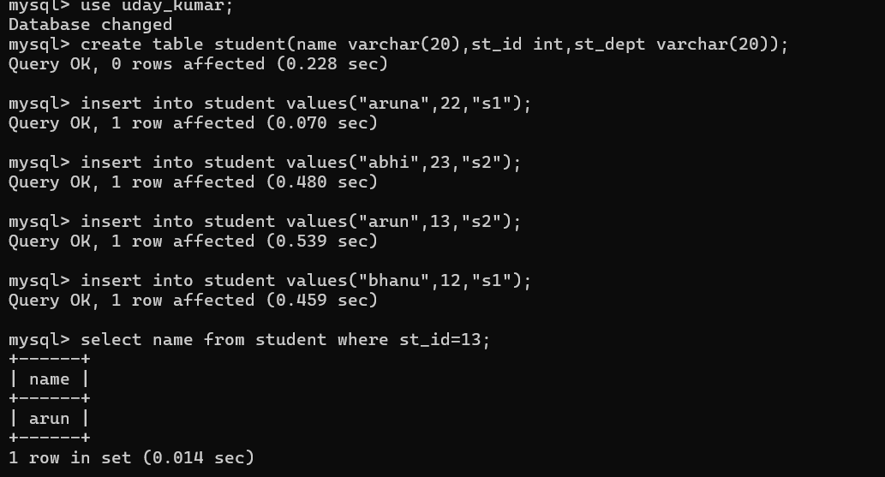
PATTERN MATCHING:
